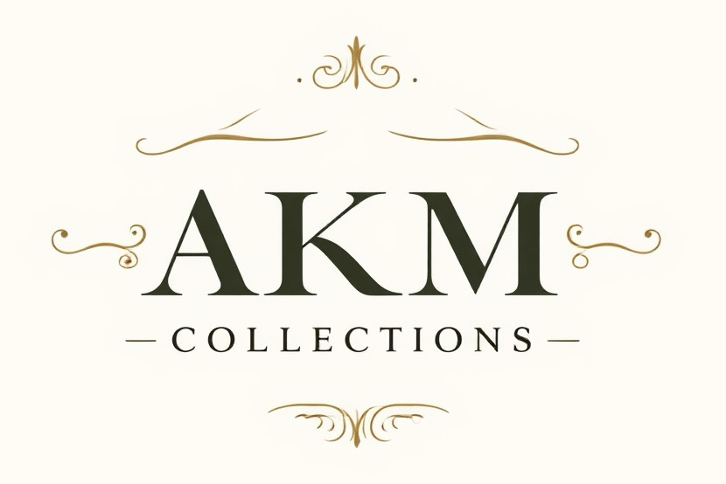
AKM Collections
Sales Consultant - Angie McGannon – 952-215-2082
Email - Angie@AKMCollections.com
www.AKMCollections.com
Elevate Your Gifting

Twin Cities Metro Area Only

- Howards Inc – Twin Cities Metro Area - Trend-right fashion jewelry, stylish hair accessories, and seasonal giftables designed for strong turns, approachable price points, and effortless add-on sales at checkout.
- Wills Company – Twin Cities Metro Area - Beautifully curated artisanal goods with a handcrafted feel—perfect for boutiques focused on meaningful gifts, storytelling, and elevated everyday décor.

Minnesota, Wisconsin

- Santa’s Workshop Inc.- Offering a wide range of seasonal, holiday, garden, and outdoor décor with strong retail appeal. Known for their handcrafted Santas, nutcrackers, ornaments, and festive home décor, the line also features licensed collegiate collections including MN Gophers and WI Badgers, making it a great fit for all retailers looking for unique regional and fan-based merchandise.
- Stony Creek at Home, Inc – NEW Stylish seasonal, inspirational and everyday home décor featuring decorative lit glass accents, candles, tabletop pieces and unique accessories designed to bring warmth, personality and charm to the home.
- Jenkins Enterprises - Boutique-friendly licensed collegiate Gopher and Badger and licensed NFL Vikings and Packer gifts that appeal to customers looking for polished team spirit rather than mass-market merchandise.
- From the Heart Jewelry - Inspirational and collegiate jewelry collections with meaningful charm stories, plus custom high school and state programs that resonate with local shoppers.

Minnesota, Wisconsin, Iowa

- A&B Home - A family-owned, international home décor and accent brand bringing a wide assortment of decorative accessories, furniture, lighting, florals, and outdoor pieces for varied interior and exterior environments.
- Continental Art Center – A wholesale garden and décor brand offering whimsical, hand-made and hand-painted outdoor art, statues, stakes, and decorative pieces to enliven patios and landscapes.
- Cheap Carls - A family-owned wholesale supplier of quality seasonal décor, lawn & garden accents, and metal stake designs across spring, summer, fall, winter, and holiday categories at competitive prices.
- Eleven-Point Candles - Hand-poured soy candles and wax melts with a clean, modern aesthetic. State pride and custom options make these ideal for boutiques wanting exclusive, locally inspired gifts.
- Southern Charm Candles - Distinctive candle designs in decorative jars that feel gift-ready right off the shelf. Strong visual appeal with custom opportunities for boutique exclusives.
- Kitchen Innovations - Thoughtfully designed kitchen tools and clever gadgets that make perfect hostess gifts, impulse buys, and practical lifestyle additions for gift-focused boutiques.
- Kinzie Foods BBQ Sauces - NEW Kinzie Foods crafts premium, small-batch BBQ sauces with bold, unexpected flavors like Pickle, Espresso, Fiery, and Ghost Pepper. Made in the USA, these versatile sauces bring a creative twist to grilling, dipping, marinades, and everyday meals.
- Charleston Custom Bags - Personalized canvas totes and bags with low minimums—ideal for boutiques looking to offer custom, logo, or locally themed pieces with great margins.
- Charleston Garden Flags - Offers colorful garden and house flags with a classic yet playful style. Featuring seasonal, coastal, everyday, and regional designs, the collection brings charm, personality, and eye-catching curb appeal to gift shops, boutiques, and garden centers.
- Bourbon & Bamboo – Where timeless sophistication meets playful charm, our collection of handbags, totes, cosmetics bags, lunch bags, and wine totes combines impeccable taste with creative flair. Our designs blend classic patterns with vibrant colors and whimsical touches, perfect for adding a pop of personality to your everyday essentials.
- Capri Designs – NEW Non-Licensed apparel! Fashion-forward clear bags with licensed team spirit appeal—ideal for boutiques serving customers headed to games, concerts, and events who still want style.
- BubbleCraft - NEW Fun, colorful 3D stickers and creative gift products featuring playful, trend-forward designs perfect for personalizing water bottles, laptops, notebooks, gifts and more.
- The Fanatic Group – NEW-TFG specializes in officially licensed collegiate and school-branded gifts, drinkware, office accessories, and customized promotional products, serving thousands of colleges, universities, and schools nationwide with high-quality, personalized merchandise.

Iowa Only

- Brosway Italian Jewelry – An Italian fashion jewelry brand known for its trend-driven, contemporary pieces crafted with Italian design and quality, offering everything from necklaces and bracelets to rings and earrings. The brand creates stylish collections for both men and women, blending modern aesthetics with versatile, everyday wearability

